**What is event loop and how it works**

See the blocks

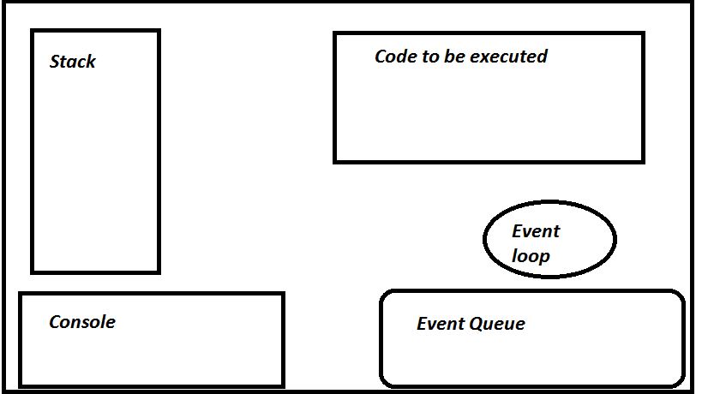

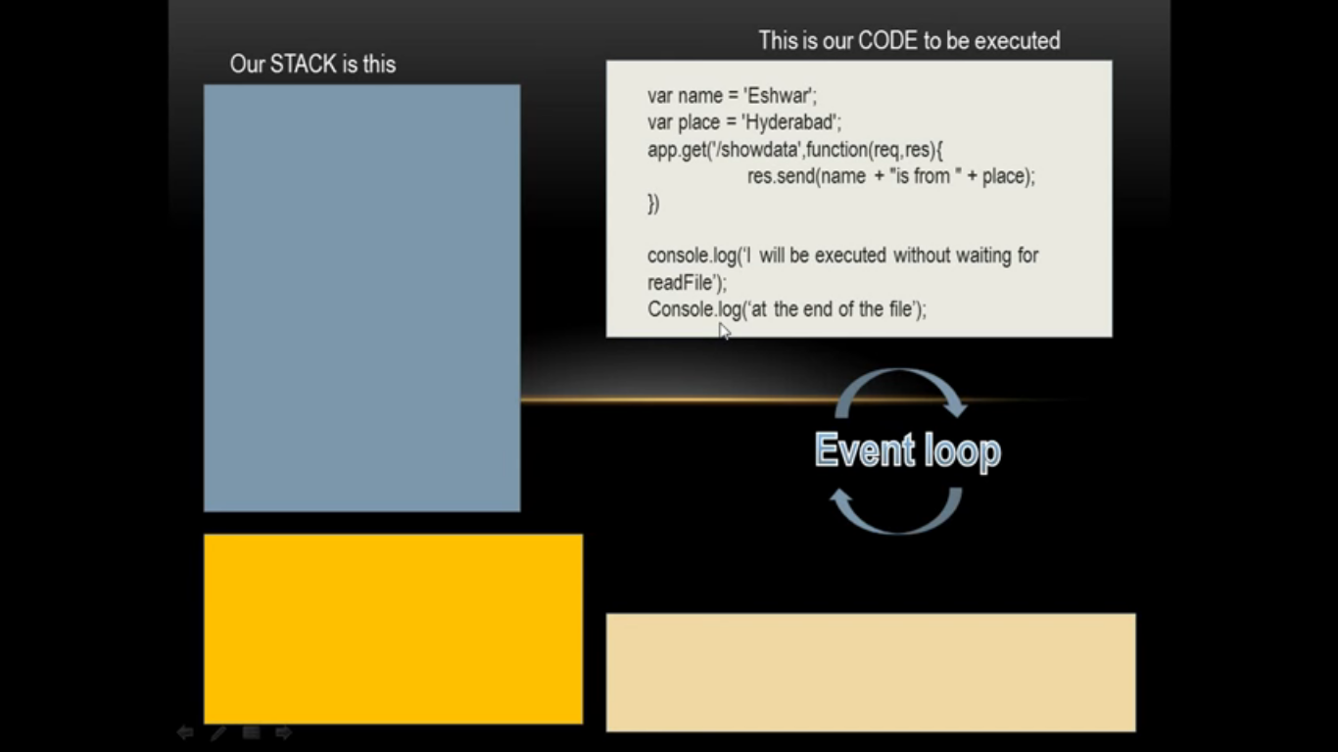

When we start executing, JavaScript is line by line execution. So the first line of code is put on to the stack.It is just a var statement so this will assing ‘Eshawar’ value to name variable and will be popped out.

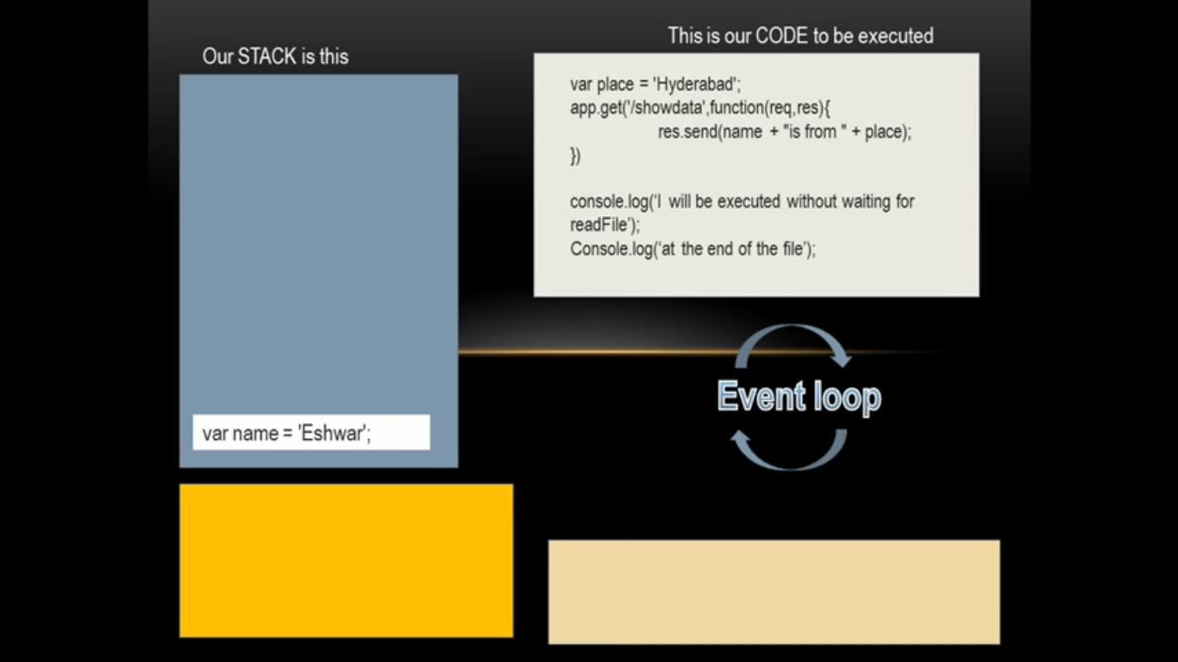

Same it will assing ‘Hyderabad value to place variable and will be popped out.

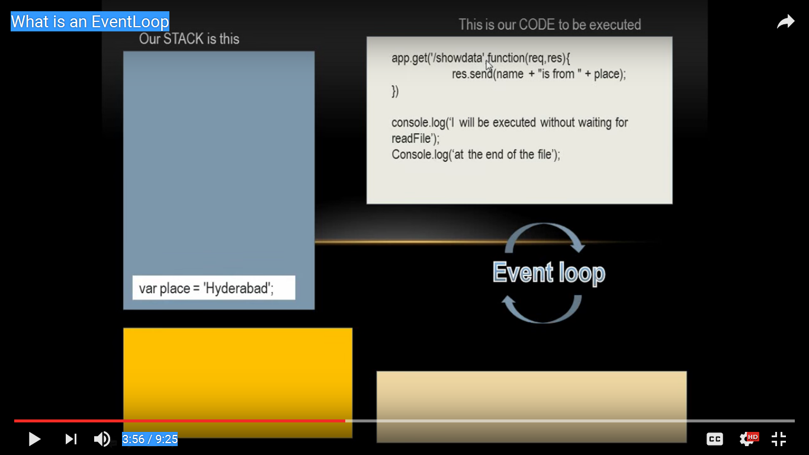

Now the event loop comes into the picture.

Now app.get statement is there to execute and it has a callback function. So event loop will take care of this part and other code execution will go future. So app.get will be pop on to the EVENT QUEUE by eventloop.

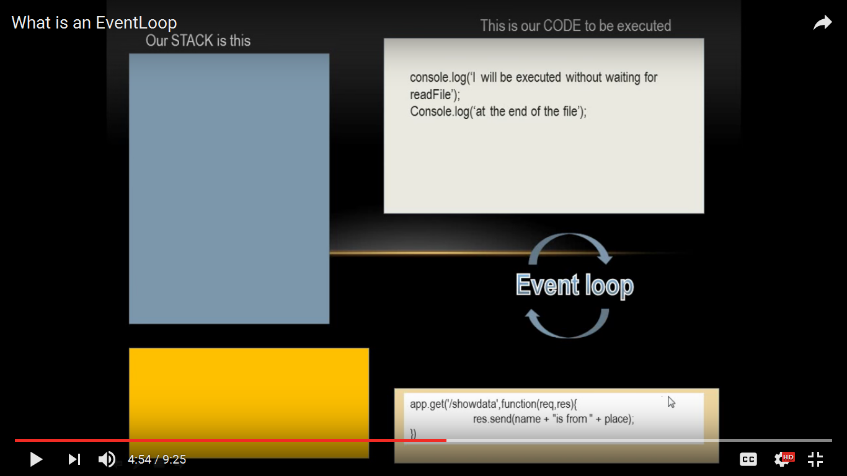

Then the console statement will be put on to the stack and printed on console and popped out from stack.

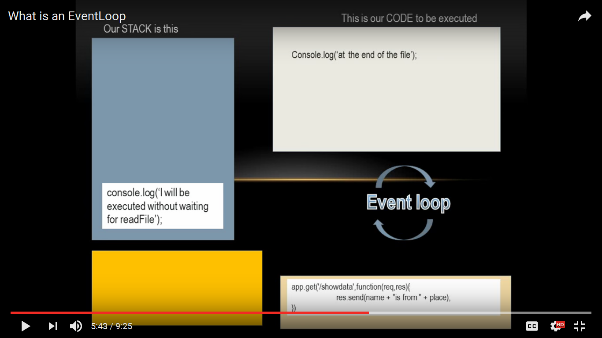

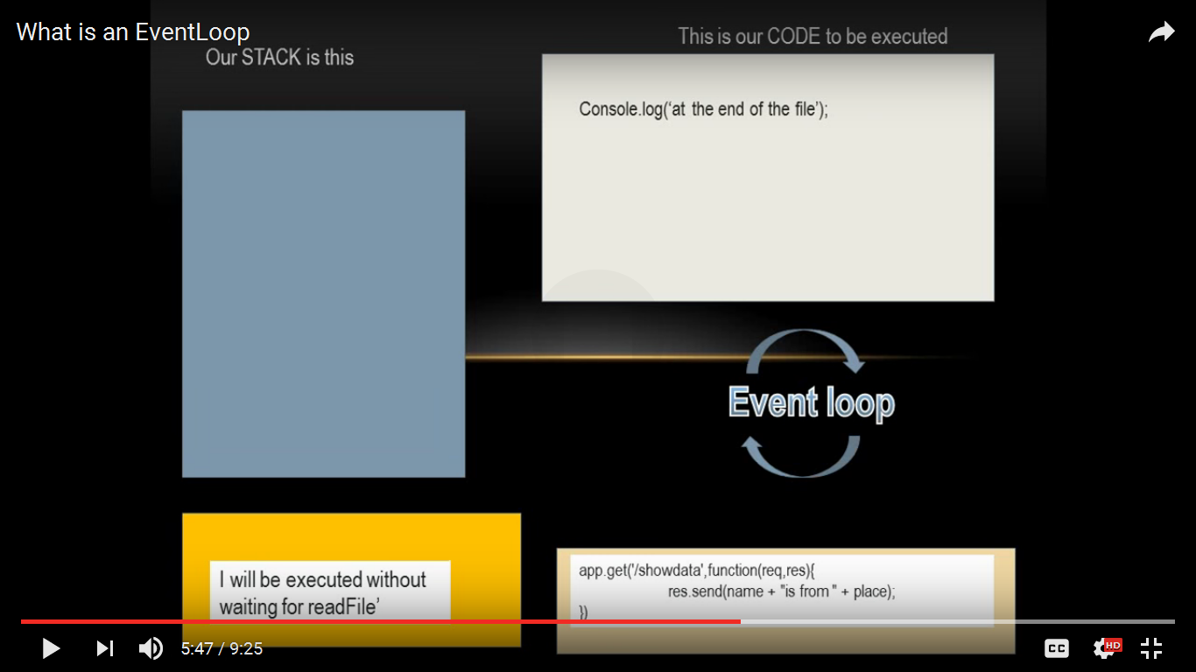

Event loop has an eye on **code to be executed** and **Stack .**If there is nothing to be executed and nothing on to the stack then both will return false . at this time the code part which is present in event queue will be put on to the stack and executed.

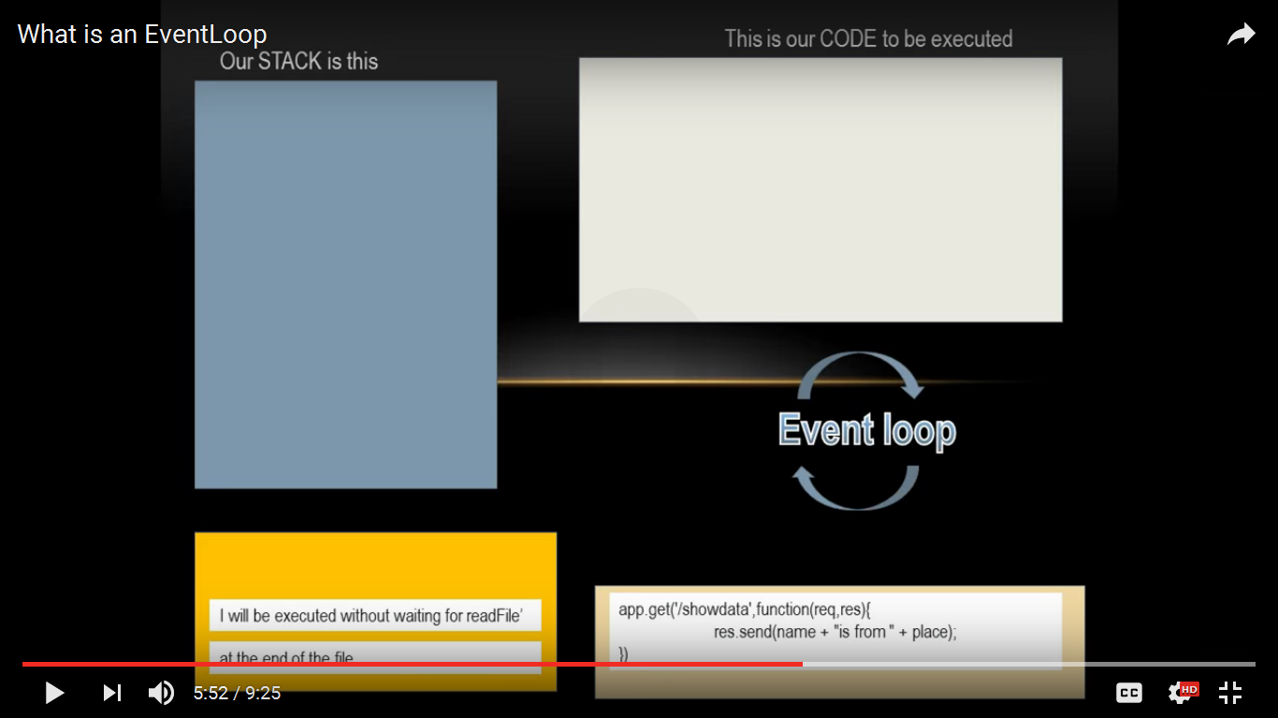

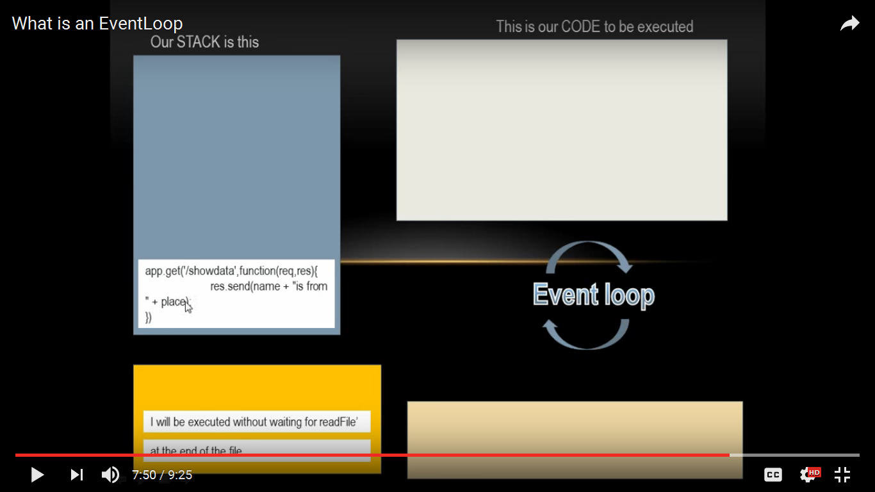

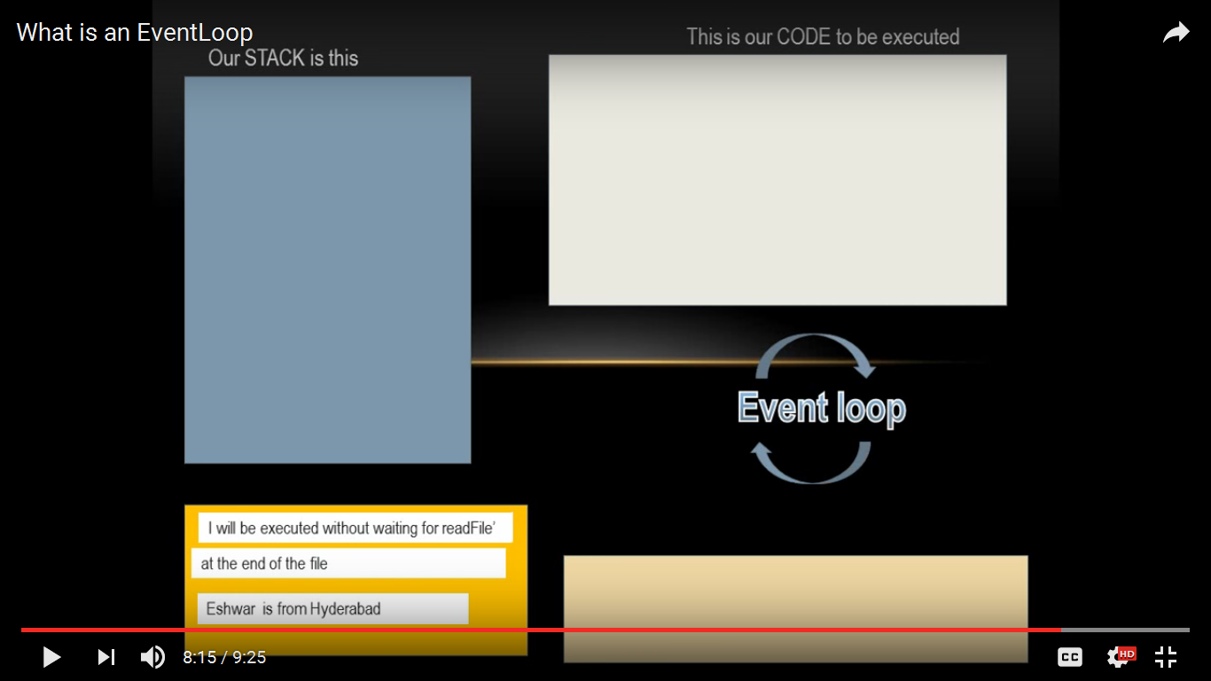

If there are more than one app.get statements then those will be put in the event queue one after another. And first will put on to the stack and the second.

Link : *https://www.youtube.com/watch?v=O1mx9WO7PAI*